Release Assembly - TC Cockpit Release One Deployment Guide

Revision History
Author | Revision Number | Date
TCSASSEMBLIER | 1.0 | Feb/16th/2012

Deployment Instructions 3
1. Organization of Submission 3
2. Application Setup 3
2.1 Configuration file setup 3
2.2 Build scripts setup 5
3. Database Setup 5
4. Deployment Instructions 5
5. Starting 5
6. Verification 6
7. Resource Contact List 9

Deployment Instructions

Organization of Submission

The submission has following directory structure:

docs

Contains this document which is the Deployment Guide this assembly.

direct

Contains all the updated and newly added sources files, statis files and configuration files for the topcoder direct application.

update_notes.txt

The required update notes which document all the updates and how the codes fix each issue

test_files

SQL script to insert some test data and help testing

query

The updated query for this assembly

Application Setup

The application is expected to be deployed to the following environment:

JRE 1.5
JBoss 4.2.3.GA
Informix DS 11.0

Configuration file setup
N/A

Build scripts setup
The build script for Direct application (build.xml) provides the following targets which are to be used:

- switch-and-checkout –checkout or switch to the defined source code branches for all components defined in subprojects.xml
- dist-backend –rebuilt all the components from the source code.
- first_deploy –must be the first task to execute from command line. It will copy all dependencies to your local JBoss folder.
- deploy –should be the main task to execute from command line. It will build and deploy WAR file.
- deploy-apache-static –deploys the static files to jboss.

You can get more information here:
http://www.topcoder.com/wiki/display/docs/TC+Direct+Setup+Guide

Database Setup
Update one query via query tool

Update direct_contest_stats_replatforming
- Go to query tool and choose TCS_CATALOG database
- Click query list and find the query direct_contest_stats_replatforming
- Use the contents in query/query_direct_contest_stats_replatforming.txt to update the chosen query and click save

Deployment Instructions

This section provides the instructions in Production environment.

- Merge the code from submission into SVN branch for Direct application
- Build and deploy Direct application using ant deploy (or ant first_deploy ) command.
- Copy static files using ant deploy-apache-static command.

Starting

- Build and deploy the Direct application
- Start JBoss server instance hosting Direct application

Verification

First you can load the test data in test_files/test-data-studio.sql into the Informix database first

Then you need to run test_files/fix_error.sql to fix the exception when adding contest fee

Before testing, please update your hosts file with
<Your VM IP> tc.cloud.topcoder.com tcs.cloud.topcoder.com cockpit.cloud.topcoder.com, this is the IP of test VM server

After deploy and the JBOSS is successfully started. Log in into the Cockpit via the page http://cockpit.cloud.topcoder.com/direct/.

Verify https://apps.topcoder.com/bugs/browse/TCCC-3898

- Log in as Hung create a direct project through right bar "Start New Project" button.
- Go to settings --> permissions. grant full permission to heffan.
- Log in as heffan. Go to settings --> contest fee, pick "Project Contest Fees Creation for Billing Accounts". Create contest fee for one billing account by setting all values as 0.
- Launch as new contest, for example, assembly, and pick the billing above
- Log in as Hung again in and edit the newly created contest. Try edit the contest fee section. hit cancel and you will notice the contest fee is still kept as 0.

You can try update the contest fee again to a non zero value and create contest, and test again.

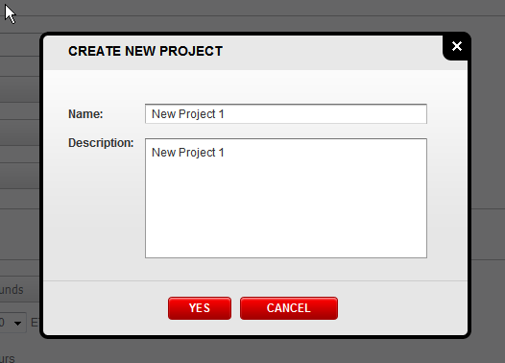

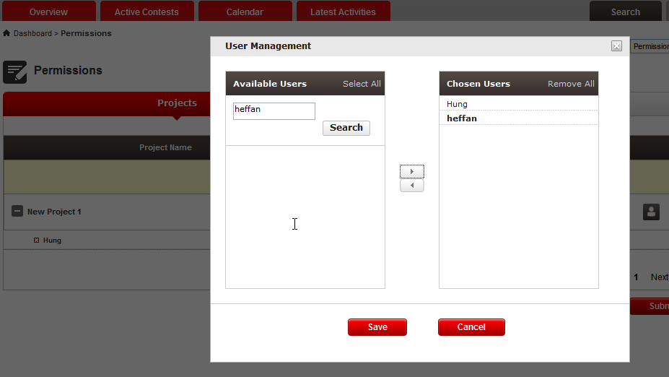
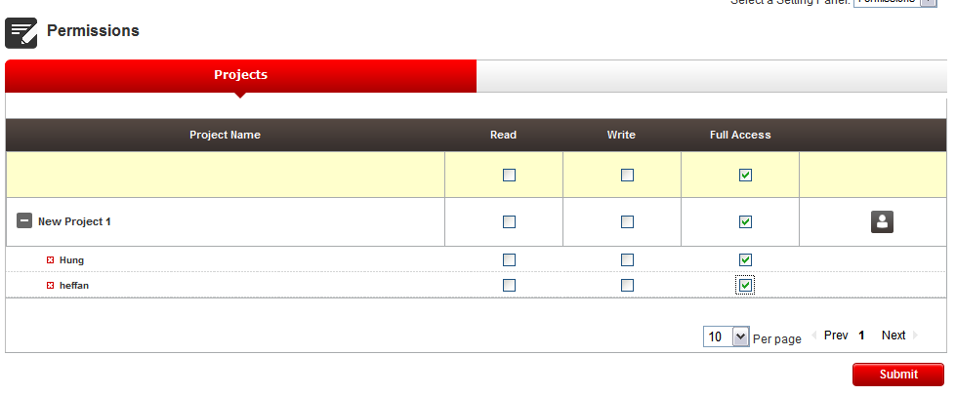

Set 50 for specification

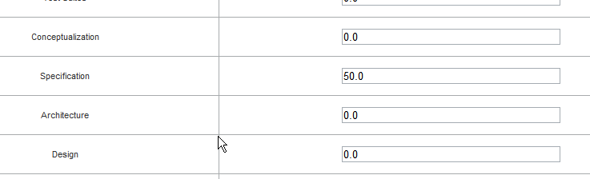

Create a specification contest with account heffan, the just edited billing account, and login as Hung to look at the contest, the contest fee is 50

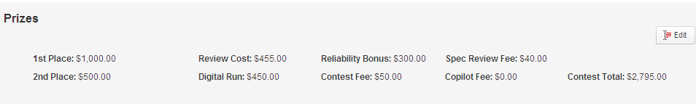

Click edit

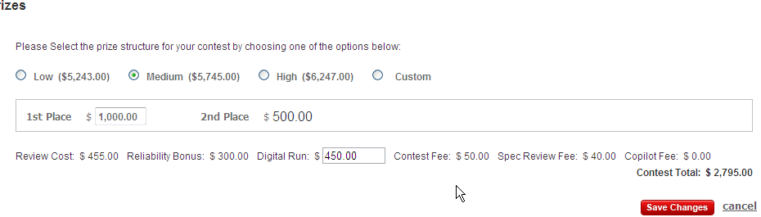

The contest fee is still 50, click cancel, the contest remains, the issue is fixed

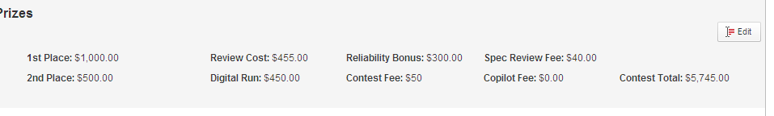

Verify https://apps.topcoder.com/bugs/browse/TCCC-3897

Go to permission page

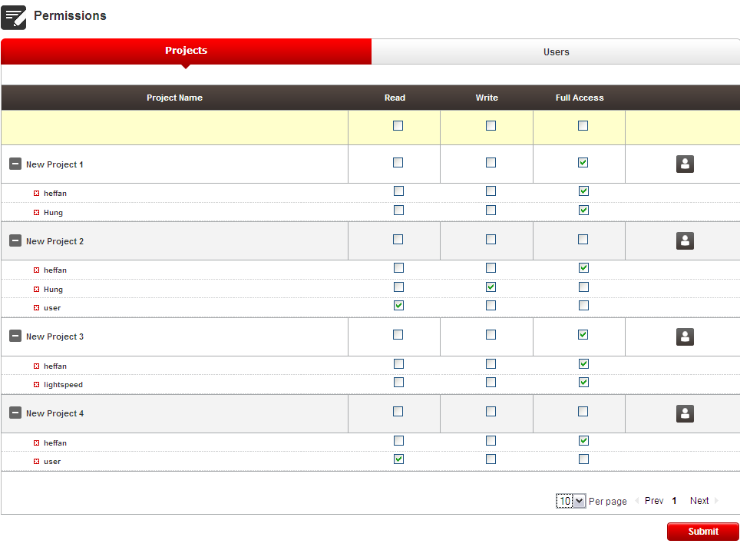

Delete Hung in new project 1, click the X

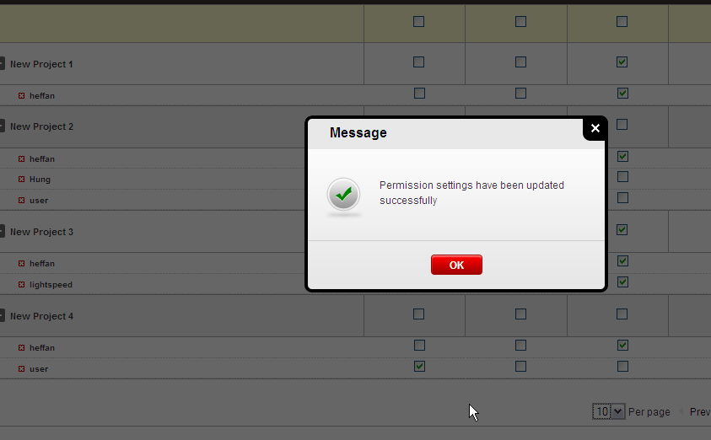

It will submit via ajax and return with a confirmation.

Try deleting myself, heffan

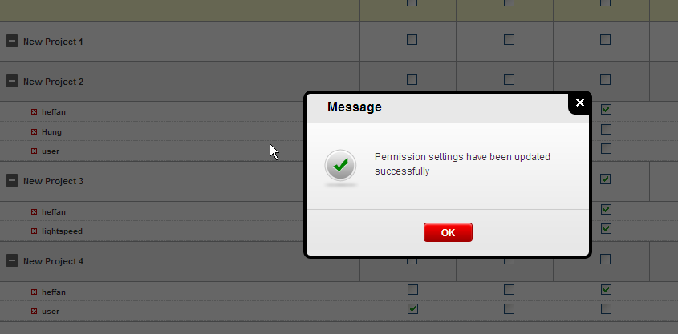

Change multiple checkboxes in the page

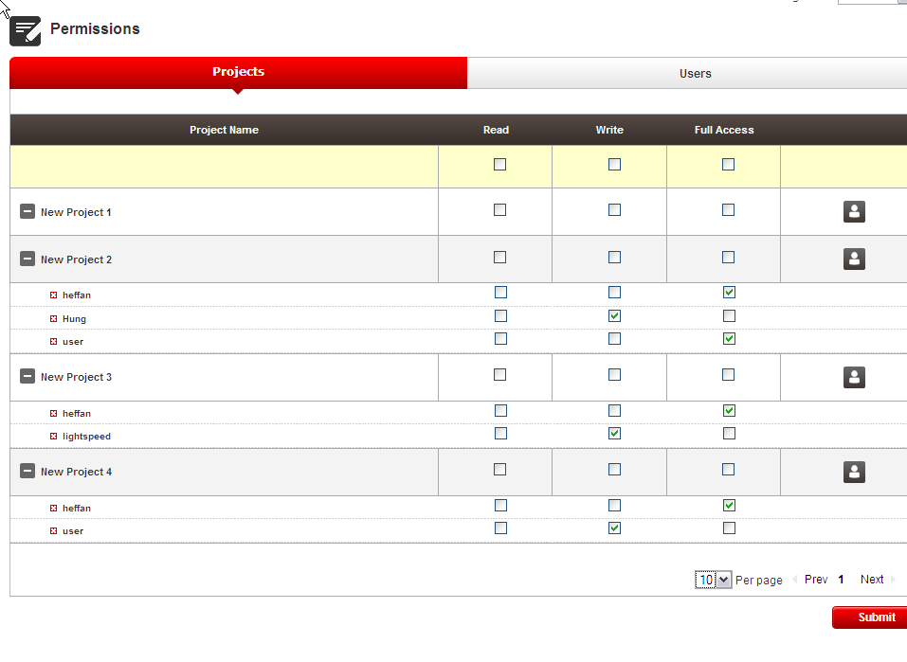
Then click submit

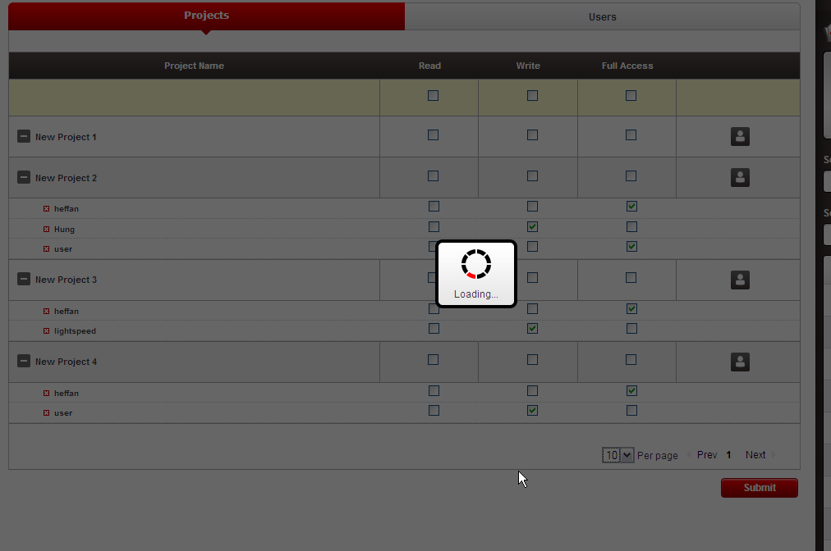

It submits via ajax and return a response

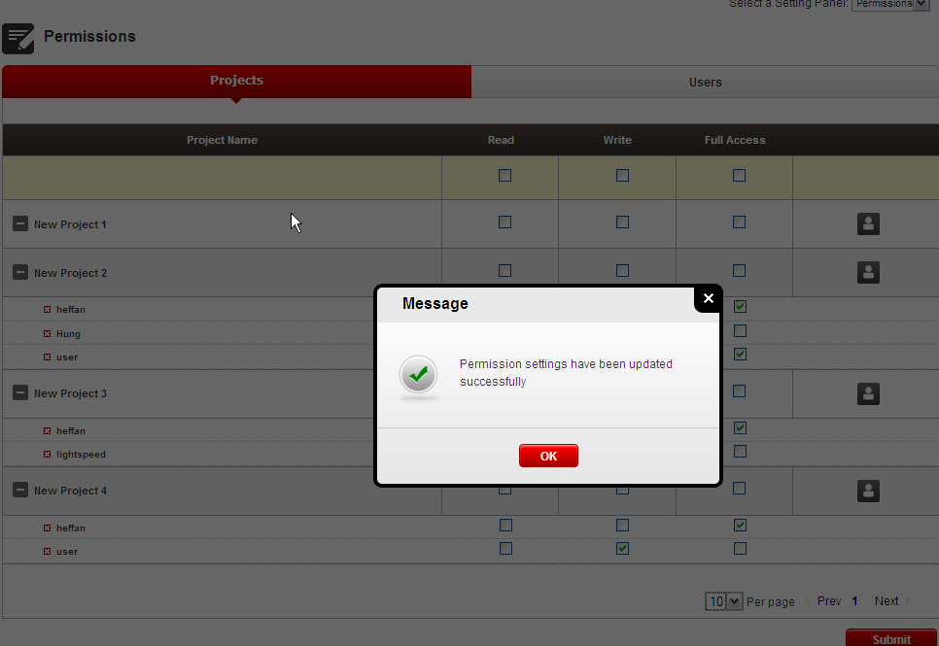

You can refresh the page to see if all the permissions are updated as needed.

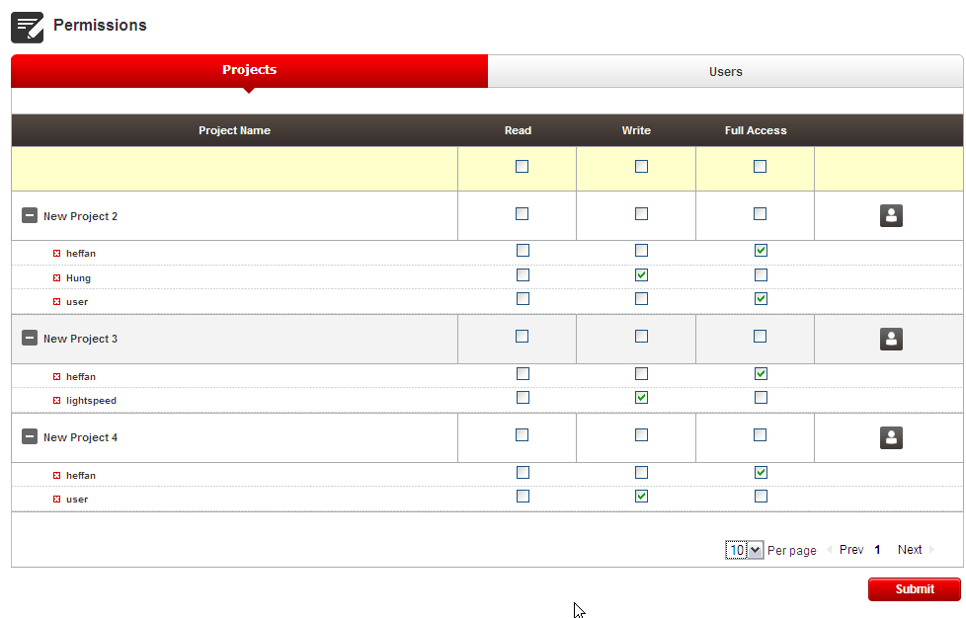

Verify https://apps.topcoder.com/bugs/browse/TCCC-3862

Create a copilot contest with 300$ and 150$ payment.

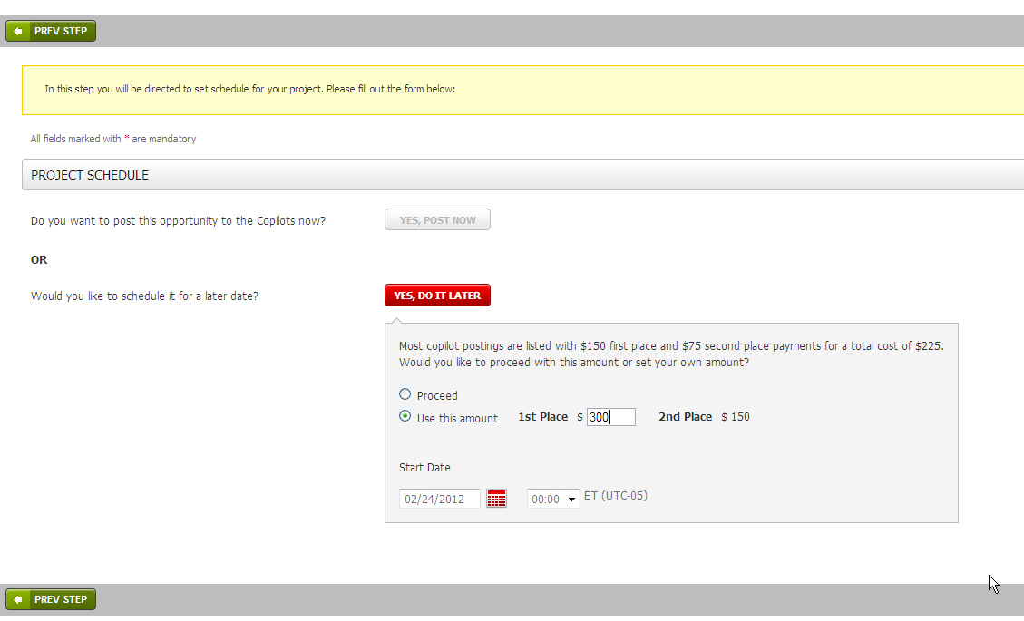

Activate the copilot contest , check the copilot contest details page in tc, it shows 300$ and 150$

Go to edit copilot posting to edit and prize and save

Check again, the prize is updated, you can also directly check the database to see after updating, whether the project info with type id 16 are updated

Verify https://apps.topcoder.com/bugs/browse/TCCC-3886

Open a multiple round studio contest

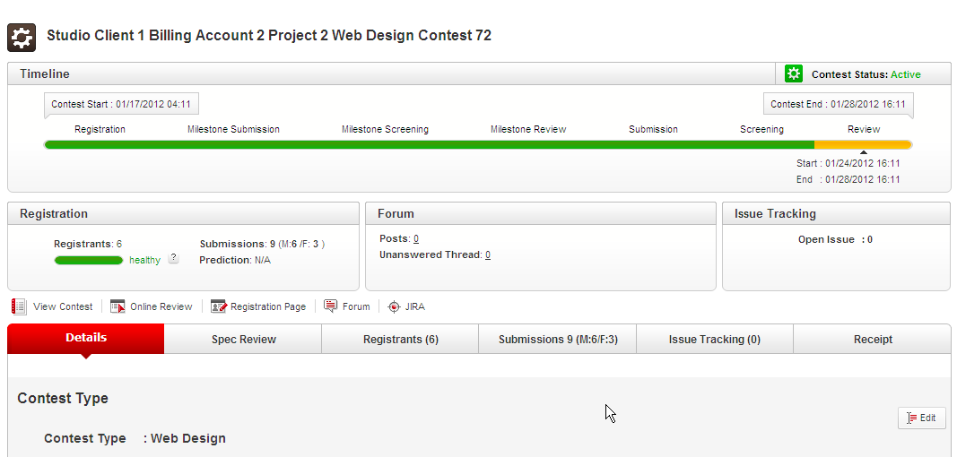

Check the registration box and submission tab

Open a single round software contest

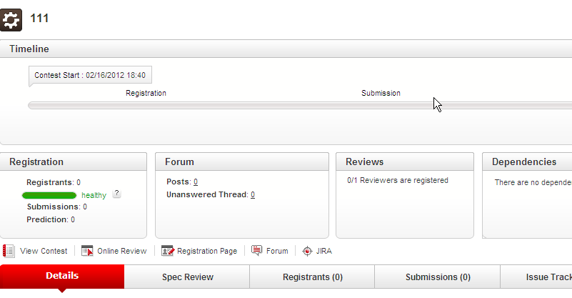

Open a multiple round software contest

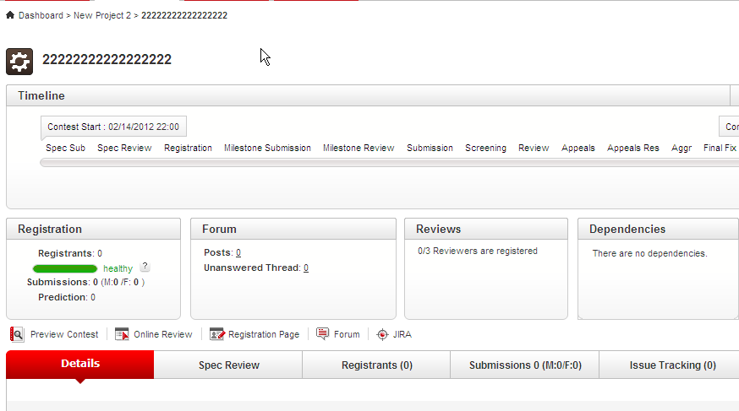

Open a single round studio contest

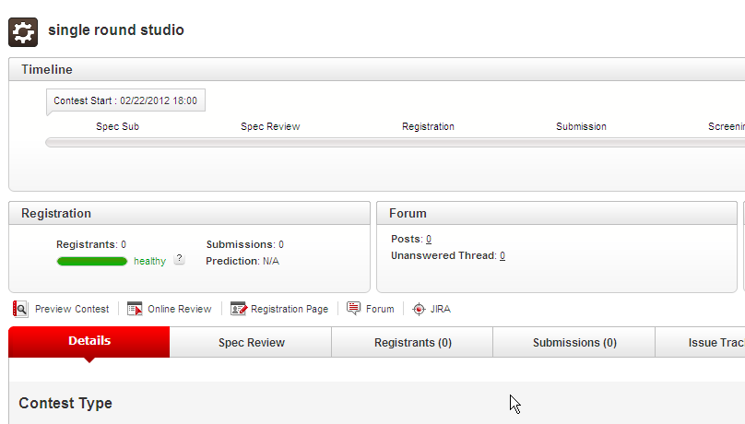

Verify https://apps.topcoder.com/bugs/browse/TCCC-3905

Open a studio contest in milestone review phase

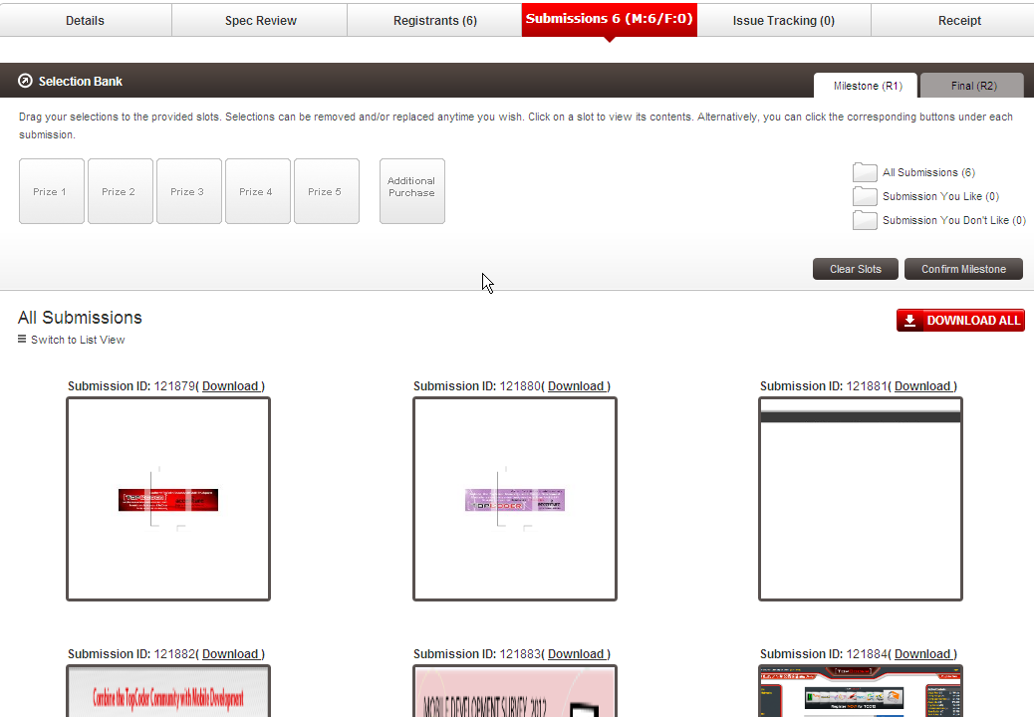

Click confirm milestone without choosing any submission

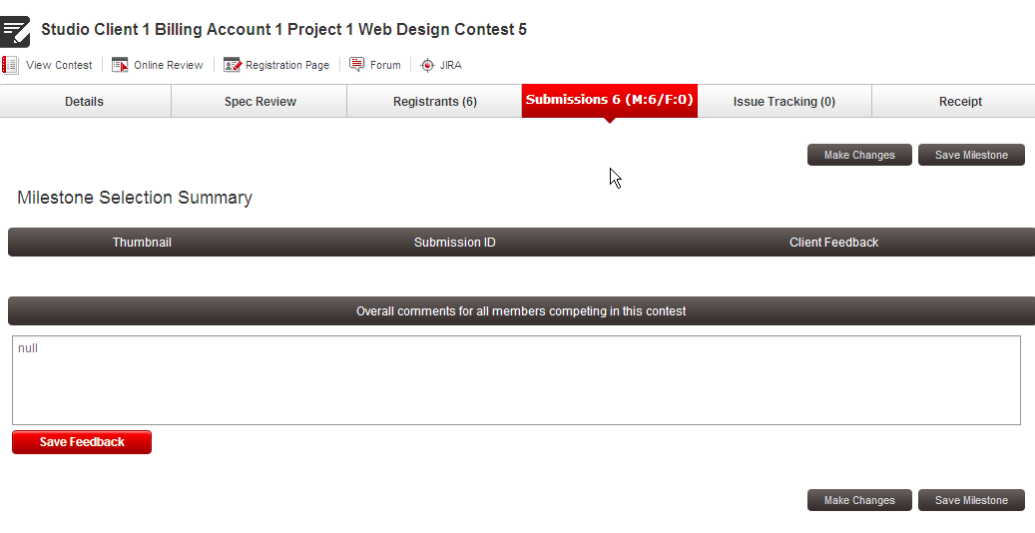

Click Save Milestone

Error is shown

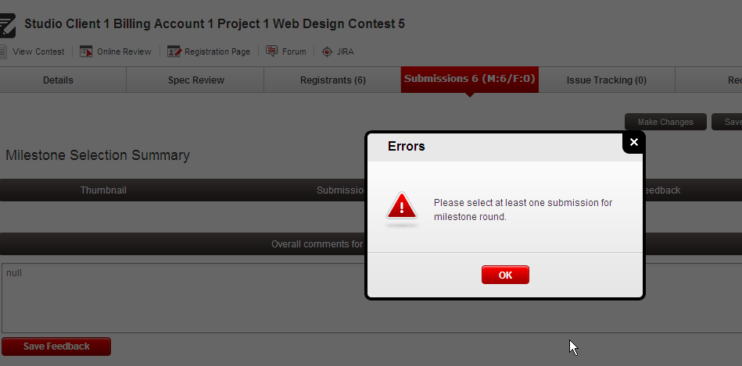

Click making changes and choose only one milestone winner

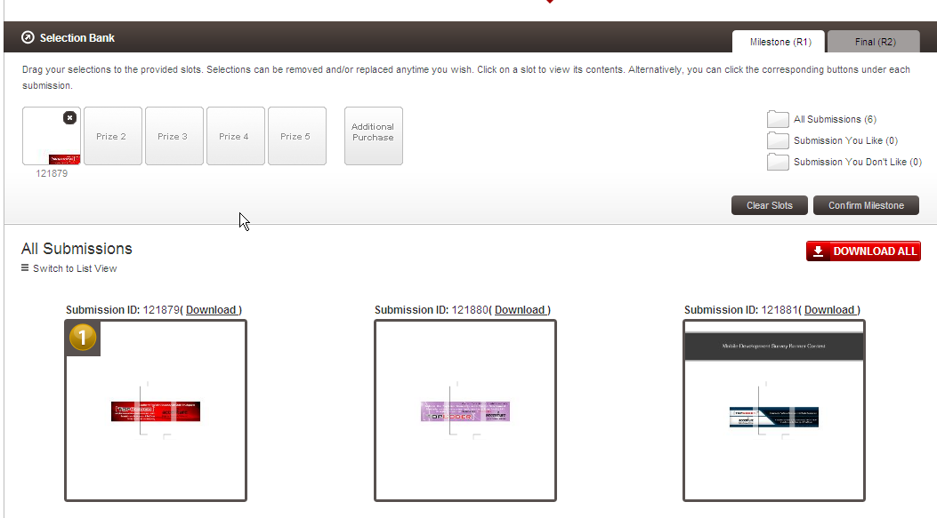

Click confirm milestone

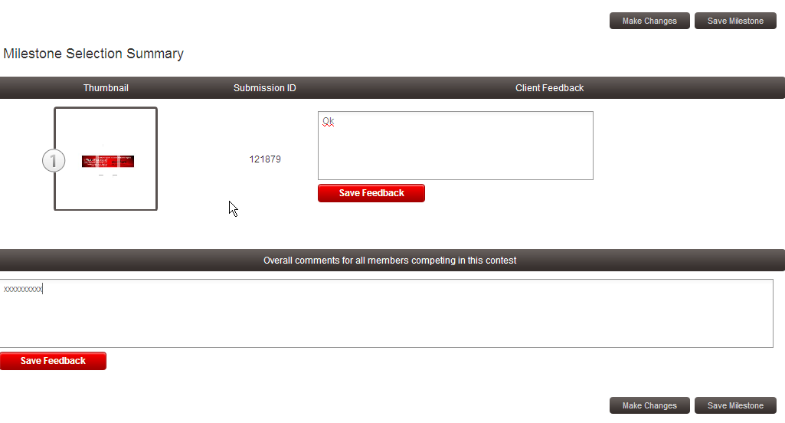

Click Save Milestone, the milestone winner is saved

You can go to the online review to see review result

Open a studio contest in review phase

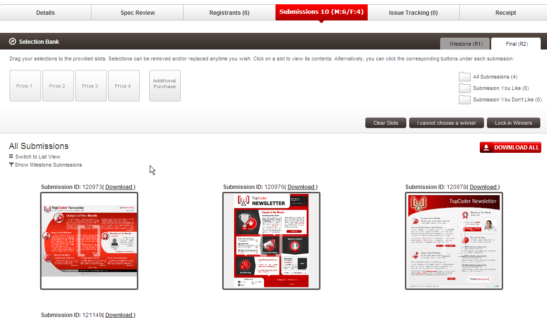

Click lock in winners without choosing a winner

Error message will be shown

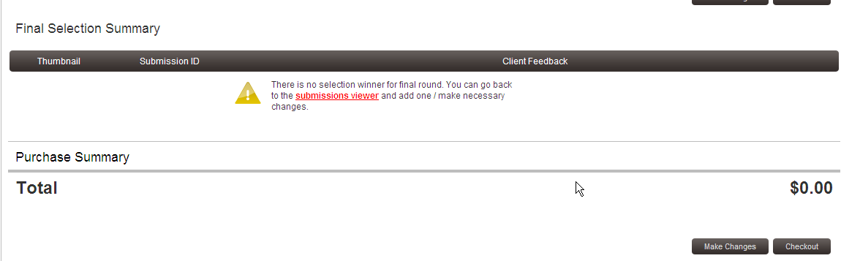

Go back and choose at least one winner

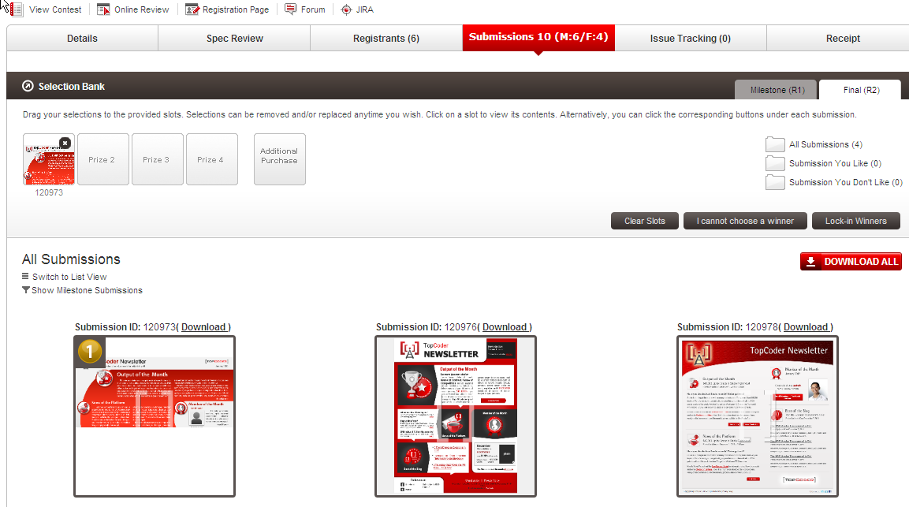

Click lock-in winner

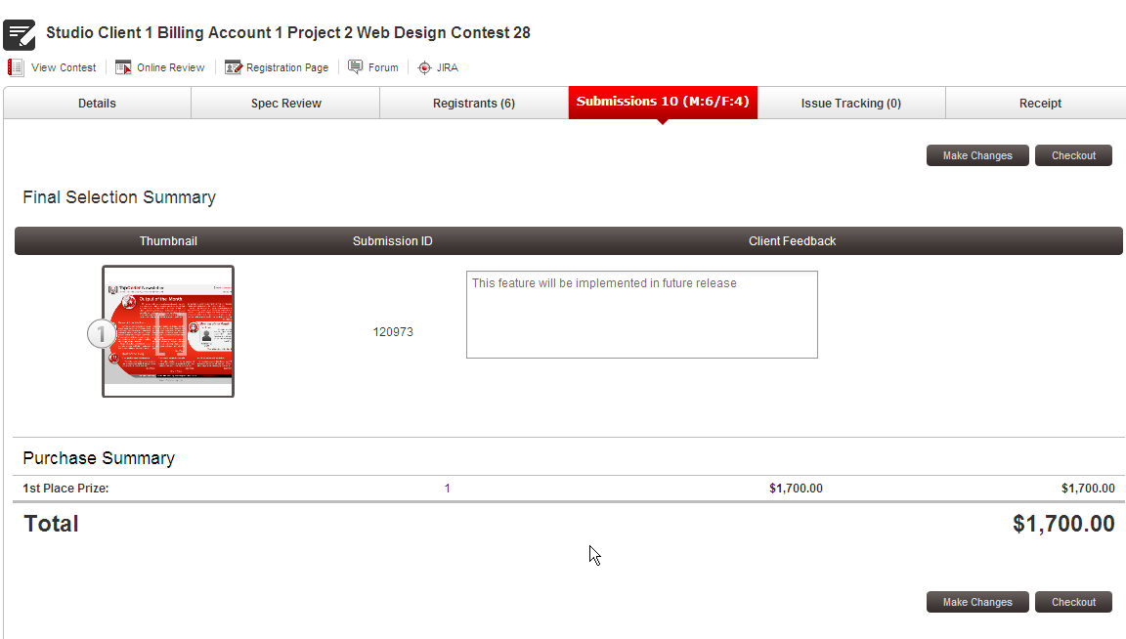

Click checkout. The winner is chosen, you can go to the online review to check the review result.

Please note that on VM, the auto copilot does not work, so the milestone review and review phase will not closed automatically, but you can close them manually.

Resource Contact List

Name | Resource Email
TCSASSEMBLER

